Background: 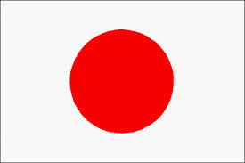
Government System of Japan
Japan is a constitutional monarchy where the power of the Emperor is very limited. As a ceremonial figurehead, he is defined by the constitution as "the symbol of the state and of the unity of the people." Power is held chiefly by the Prime Minister of Japan and other elected members of the Diet, while sovereignty is vested in the Japanese people. Akihito is the current Emperor of Japan; Naruhito, Crown Prince of Japan, stands as next in line to the throne.
Constitution:
The Constitution of Japan is the fundamental law of Japan. It was enacted on 3 May 1947 as a new constitution for postwar Japan. The constitution provides for a parliamentary system of government and guarantees certain fundamental rights. Under its terms the Emperor of Japan is "the symbol of the State and of the unity of the people" and exercises a purely ceremonial role without the possession of sovereignty.
Emperor:
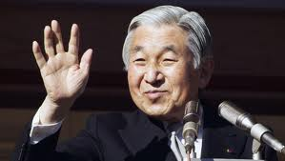The Emperor of Japan is the ceremonial monarch in Japan's system of constitutional monarchy and is the head of the Japanese Imperial Family. According to Japan's 1947 constitution, which dissolved the Empire of Japan, he is "the symbol of the state and of the unity of the people." He is also the highest authority of the Shinto religion as he and his family are said to be direct descendants of Amaterasu.
Legislature:
The Japanese parliament is called the Diet. It consists of the House of Representatives (480 members) and the House of Councillors (242 members). The members of the Diet are elected by the Japanese people.
Executive branch:
The executive branch reports to the Diet. The chief of the executive branch, the Prime Minister, is appointed by the Emperor as directed by the Diet. He must be a member of either house of the Diet and a civilian. The Cabinet, which he organizes, must also be civilian. The Constitution states that the majority of the Cabinet must be elected members of either house of the Diet, the precise wording leaving an opportunity to appoint non-elected officials.
Local Government:
Japan has a unitary system of government in which local jurisdictions largely depend on national government financially. The Ministry of Internal Affairs and Communications intervenes significantly in local government, as do other ministries. This is done chiefly financially because many local government jobs need funding initiated by national ministries. This is dubbed as "thirty-percent autonomy”.

